Give sufficient working out to obtain full marks in any questions involving calculations. Give ALL numerical answers correct to 3 significant figures unless otherwise stated or required by the given data.

Section A: Short answers

1. Identify the poles of the magnets whose 2-D field lines are shown. [4]
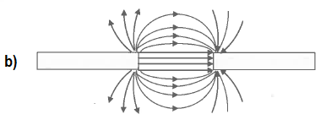
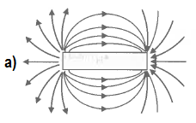

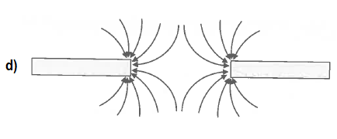
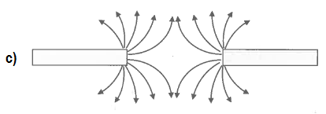

2. The horizontal magnetic field strength due to the Earth${ B}_{HE}$, at a certain location, has the same magnitude as the magnetic field strength due to any pole of the two magnets shown of equal strength at the locations marked $A, B, C and D.$ Sketch the resultant magnetic field at each of those locations due to a combination of the magnets and the Earth’s horizontal magnetic field. Consider only the effect of the pole(s) closest to the points and the Earth’s field. [4]

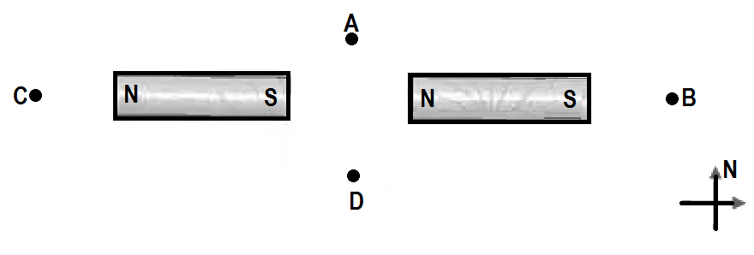

3. On the map of the world provided, mark the following:
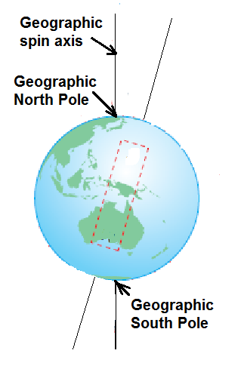
(i) The Magnetic North Pole [1]
(ii) The Magnetic South Pole [1]
(iii) 8 magnetic field lines
symmetrical about the magnetic
axis. [4]

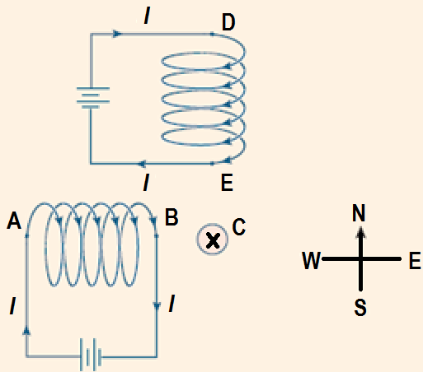
4. The diagram shows two current-carrying solenoids located equidistant from and at right angles to a long, straight, current-carrying conductor$C$ (perpendicular to page) that carries a current into the page.
The magnitude of the magnetic force due to the solenoids on C is 5.00 µN.
(a) In what direction is the magnetic force on$C$? [1]

(b) The direction of the current in the solenoid$DE$ is reversed and its magnitude halved. The current in conductor $C$ is also reversed and its magnitude doubled. Calculate the force on conductor$C$now? [3]

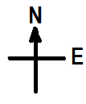
5. Each diagram below shows 50.0 cm of current-carrying conductor within a magnetic field. Calculate the force acting on each conductor due to the magnetic field.
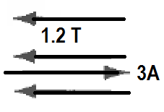
a) [2]

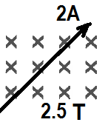

b) [2]

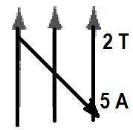
c) [2]

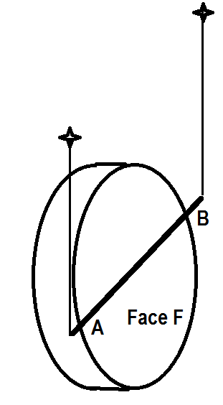
6. In an experiment students suspended a copper wire $AB$beside a face $F$ of a disc magnet as shown. They noticed that when the wire was connected to a $DC$ supply, it moved up (was levitated).
a) Which choice correctly shows the direction of the current in the wire and the polarity of the face$F$? Circle the correct one. [1]
(A) Current from $A to B$ and face $F$ polarity is north.
(B) Current from B to A and face $F$ polarity is south.
(C) Current from B to A and face $F$ polarity is north.
b) Explain in detail your choice. You must draw appropriate magnet field interaction diagrams and a simple mention of the right hand slap rule is not sufficient. [3]

7. Transformers are devices that step up and step down voltages for many applications.
a) Why are transformers laminated? [2]

A 75% efficient transformer is needed to supply two 12−Ω globes an RMS output voltage of 60.0 V. The input voltage is 3.0 V RMS.
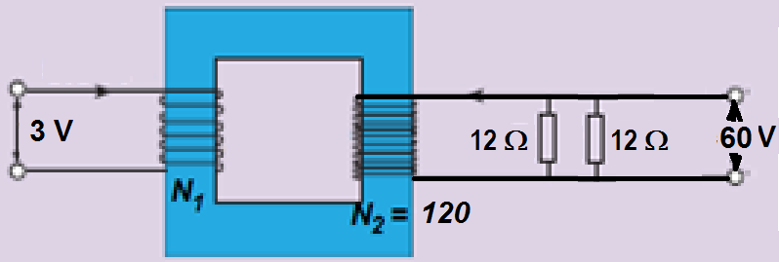

There are 120 turns in the secondary winding.
a) What is the RMS output current? [1]

b) How many turns are there in the primary winding? [1]

c) How much power is generated by the input source? [1]

d) What is the peak input current? [1]

Section B. Calculations

8. The following is a simplified diagram of a DC motor
(a) Briefly write down the functions of the following parts.
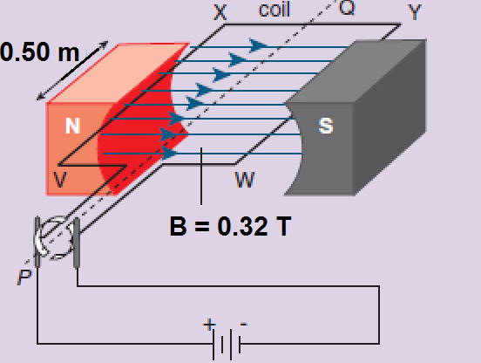
(i) Battery [1]

(ii) Soft iron core or armature (not shown) [1]

(iii) Split ring commutator [1]

(iv) Carbon brushes [1]

(b) The coil shown has 100 turns. The side XY is 1.00 m. and caries a current of 0.50 A. Calculate the magnetic force on the following sides at the instant shown:
(i) VX [1]

(ii) XY [1]

(iii) YW [1]

(c) Calculate for the instant shown, the torque on the coil and state which direction the coil will rotate (clockwise or anticlockwise) as viewed from the split ring side. [2]

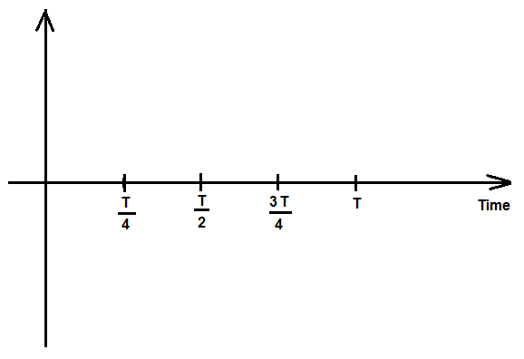
(d) Sketch a torque versus time graph for one complete rotation, using the shown position as zero time. [2]

(e) List four ways in which the DC motor could be modified so the maximum torque could increase. [2]

(g) Motors can be used as generators if they are modified in a certain way. How could this motor be converted into a generator? [2]

(h) If the motor was modified and converted into a generator, would the generator produce AC or DC current? Explain briefly. [1]

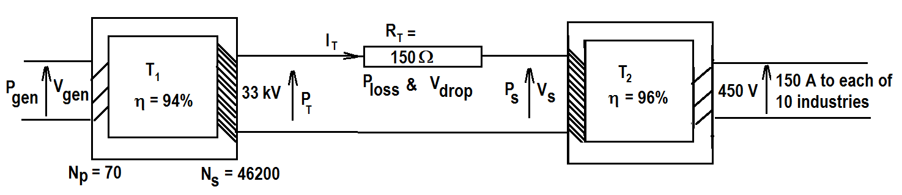
9. An industrial estate with 10 industries each needing $150 A$ at $450 V$ is supplied by a generating station. The generated voltage, $V_{gen}$ is stepped up to $33 kV$ across a $94\%$ efficient transformer$T_{1}$. The input coils to $T_{1 }$have $70$ turns and the output coils have $46200$ turns. The transmission line total resistance${ R}_{T}$ is$150$. At the substation to the industrial estate, the input voltage $V_{s}$to a second $96\%$ efficient transformer$T_{2}$ is stepped down to the required$450 V$.

a) What is the total current drawn by the ten industries? [1]

b) What is the power output to the industrial estate? [2]

c) What is the power input $P_{s}$ to the substation transformer$T_{2}$? [2]

d) What is the generated voltage,$V_{gen}$? [1]

e) Write an expression for the transmission line current $I_{T}$ in terms of$P_{s} and V_{s}$.
[1]

f) Calculate the power output of the generator$P_{gen }$. [2]

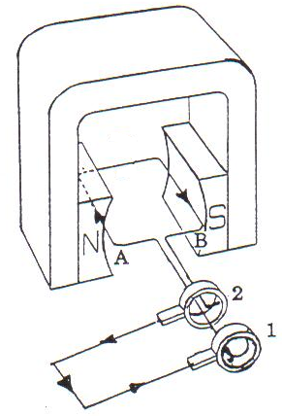
10. The diagram below is that of a simple AC generator. At the instant shown the emf generated produces current as indicated.
a) Which direction is the coil spinning? (Clockwise or anticlockwise? As viewed from the commutator’s end.) [1]

b) The magnetic field in the coil area is of intensity 0.45 T. The 20 cm × 20 cm coil has 150 turns and is spinning at 3000 rpm. Calculate:
(i) The frequency of rotation of the coil in Hz. [1]

(ii) The flux linking the coil at this position. [1]

(iii) The flux linking the coil after ¼ turn from the horizontal position shown. [1]

(b) Sketch the following graphs for one full cycle.
(i) Flux Φ versus time graph [2]
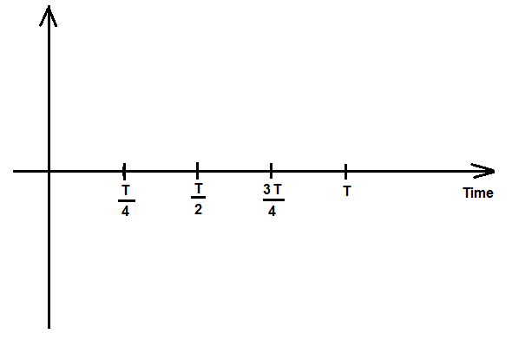

(ii) The induced EMF versus time graph. [2]



c) What changes would be observed in the induced emf if the coil was spun at 9000 rpm? [2]

iv) What changes would be observed in the induced emf if the coil was spun at 1500 rpm? [2]

Section C: Experimental interpretation:
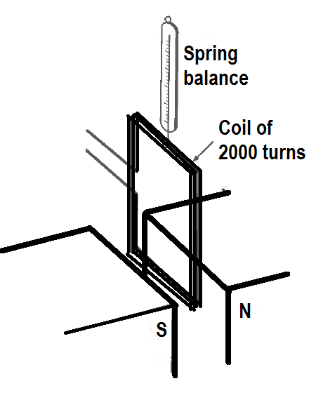
11. A group of students set up a 2000 turn rectangular coil of wire suspended from a spring balance so that its lower side (5 cm in length) was between the poles of a magnet as shown in the diagram.
They passed various currents through the coil and recorded the reading on the spring balance. Their results are shown.

Current in coil (A) | Reading on balance (N)
0 | 3.7
1 | 3.8
2 | 3.9
3 | 4.0
4 | 4.1
5 | 4.2

a) Identify three factors that have been controlled. [3]

b) Identify the dependent variable. [1]

c) Identify the independent variable. [1]

d) Determine which direction the current must floe in the coil as viewed from the left to produce the experimental results. (Clockwise or anticlockwise?) [1]

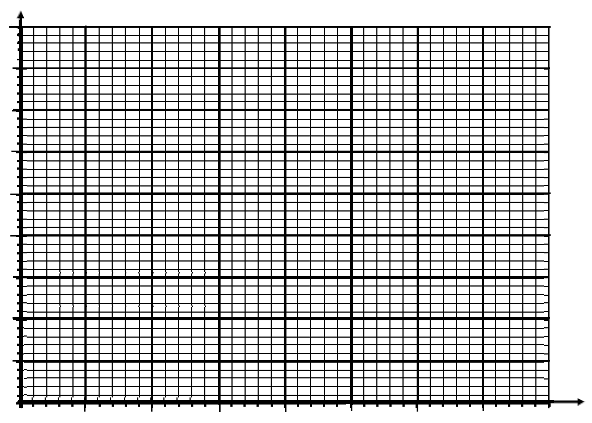
e) Graph the results of the experiment. [4]
f) Analyse the graph and the related equations from your formula sheets to calculate the following:
i) Mass of the coil. [1]

ii) Strength of the magnetic field. [2]

iii) Reading of the spring balance if a current of 12.0 A was flowing in the coil. [2]

iv) Reading of the spring balance if a current of 5.0 A was flowing in the opposite direction through the coil. [2]

v) The students repeated the experiment with the same coil but with a magnet twice as strong. On your axes above, draw and label a second graph to predict what their results would be. [1]

vi) The students then repeated the original experiment again, this time using a coil with 1000 turns. Graph and label the results you would expect on the same axes above. [1]

END OF TOPIC TEST

